Smart Disaster Relief Coordination Platform

1. Analyze System Requirements

System Objectives
The Smart Disaster Relief Coordination Platform is designed to provide a centralized, intelligent, and real-time solution for managing disaster response activities. The primary objective is to improve coordination among government agencies, emergency responders, hospitals, NGOs, volunteers, and affected citizens during disasters such as floods, earthquakes, cyclones, and wildfires. The system enables rapid incident reporting, efficient resource allocation, real-time communication, and AI-assisted decision-making to reduce response time and save lives.

Functional Requirements
The system should provide the following functionalities:
- User registration and secure authentication.
- Disaster reporting with GPS location, images, and descriptions.
- Real-time incident monitoring dashboard.
- AI-based disaster severity prediction.
- Resource management for food, medicine, shelters, and rescue equipment.
- GPS tracking of rescue teams and emergency vehicles.
- Volunteer registration and task assignment.
- Emergency notification through SMS, Email, and Mobile Push Notifications.
- Shelter and hospital locator.
- Communication between agencies through chat and alerts.
- Report generation and analytics.
- Administrator dashboard for monitoring and management.

Non-Functional Requirements
The platform should satisfy several quality requirements:
- Performance: Process disaster reports and notifications with minimal delay.
- Security: Secure authentication, encrypted communication, and role-based access control.
- Reliability: Continue operating during network failures and disasters.
- Availability: Provide 24/7 uninterrupted service with cloud deployment.
- Scalability: Handle thousands of concurrent users during emergencies.
- Maintainability: Allow easy updates and addition of new services.
- Usability: Provide an intuitive interface for users with different technical skills.
- Interoperability: Integrate with GPS services, weather APIs, IoT devices, and government systems.

Key Quality Attributes
Quality Attribute | Importance
Scalability | Supports increasing disaster reports and users.
Reliability | Ensures uninterrupted emergency operations.
Availability | Keeps services online throughout disasters.
Security | Protects sensitive citizen and emergency data.
Performance | Enables real-time response and communication.
Maintainability | Simplifies system updates and future enhancements.

2. Select a Suitable Software Architecture

Selected Architecture
Hybrid Microservices + Event-Driven Architecture

Justification
A Hybrid Microservices and Event-Driven Architecture is the most suitable choice because disaster management systems require independent services, high scalability, and real-time communication.
Each business function is implemented as an independent microservice, allowing individual deployment, scaling, and maintenance. Event-driven communication ensures immediate notification whenever a disaster report, resource update, or rescue request occurs. This architecture minimizes service dependencies and improves fault tolerance, making it ideal for emergency situations where system availability is critical.

3. Software Architecture Diagram

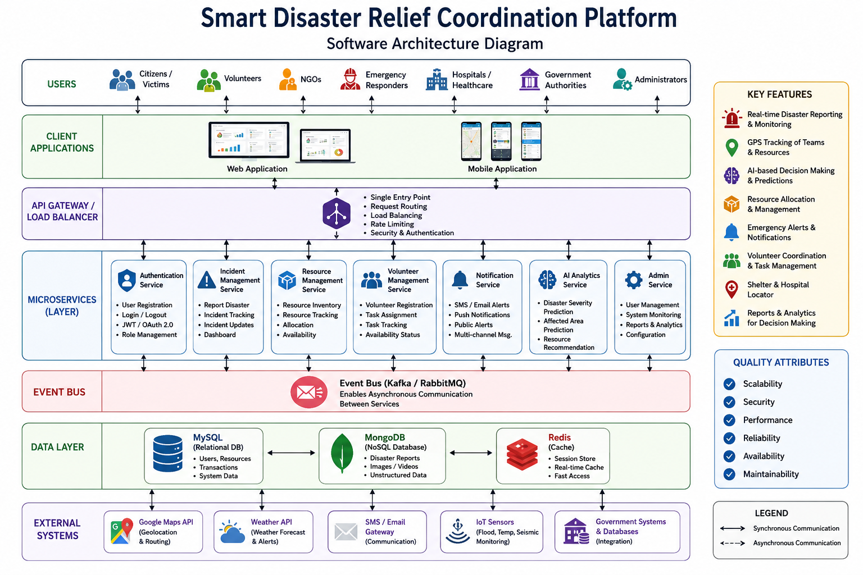

4. Components and Their Interactions

1. Client Applications
Users access the platform through web and mobile applications. Citizens can report disasters, volunteers can register for rescue operations, and administrators can monitor ongoing incidents.

2. API Gateway
The API Gateway acts as a single entry point for all client requests. It performs authentication, request routing, rate limiting, and load balancing before forwarding requests to appropriate services.

3. Authentication Service
This service manages user registration, login, password management, JWT token generation, and role-based access control.

4. Incident Management Service
It receives disaster reports, stores incident details, validates information, and updates the incident dashboard.

5. Resource Management Service
This service tracks emergency resources such as food, medicine, shelters, ambulances, rescue equipment, and emergency supplies.

6. Volunteer Management Service
The volunteer service registers volunteers, assigns rescue tasks, tracks availability, and monitors task completion.

7. Notification Service
This component sends emergency alerts using SMS, Email, Mobile Push Notifications, and public warning systems.

8. AI Analytics Service
AI algorithms analyze disaster reports, estimate severity levels, predict affected areas, and recommend optimal resource allocation.

9. Event Bus
The Event Bus (Kafka or RabbitMQ) enables asynchronous communication between microservices. When a disaster is reported, events automatically trigger notifications, AI analysis, and resource allocation.

10. Database Layer
The platform uses:
- MySQL for structured operational data.
- MongoDB for disaster reports and multimedia.
- Redis for fast caching and session management.

11. External Systems
The platform integrates with:
- Google Maps API for GPS tracking.
- Weather APIs for disaster forecasting.
- SMS and Email gateways for alerts.
- IoT Sensors for flood, temperature, and seismic monitoring.

Overall Workflow
- A citizen reports a disaster through the mobile application.
- The API Gateway authenticates the request.
- Incident Service stores the report.
- An event is published to the Event Bus.
- AI Analytics predicts disaster severity.
- Resource Service allocates emergency resources.
- Notification Service sends alerts.
- Volunteers receive assignments.
- Rescue teams navigate using GPS.
- Administrators monitor progress through the dashboard.

5. Quality Attributes

Scalability
Independent microservices can scale horizontally according to demand. Cloud infrastructure automatically increases resources during large-scale disasters.

Security
Security is achieved through HTTPS communication, JWT authentication, OAuth 2.0, encryption, role-based access control, API Gateway security policies, and secure cloud storage.

Performance
Redis caching, asynchronous messaging, cloud load balancing, and distributed databases ensure fast processing and minimal response time.

Reliability
Microservices isolate failures so one service failure does not affect others. Event queues ensure no disaster reports are lost even during temporary outages.

Maintainability
Independent services simplify debugging, testing, deployment, and future updates. Continuous Integration and Continuous Deployment (CI/CD) pipelines further improve maintainability.

Availability
Cloud deployment with multiple availability zones, automatic failover, database replication, backups, and load balancers provide 24/7 service availability.

6. Justification of Architectural Decisions
The Hybrid Microservices and Event-Driven Architecture was selected because it supports the high scalability, flexibility, and reliability required for disaster management systems. Independent services allow rapid development, testing, and deployment without affecting other modules. Event-driven communication enables instant notifications and real-time coordination among all stakeholders.
Although this architecture is more complex than traditional Layered Architecture and requires additional infrastructure such as API Gateways, message brokers, and service discovery, its benefits significantly outweigh these challenges. It provides excellent fault isolation, supports cloud-native deployment, and enables efficient handling of high user traffic during emergencies.
The modular design also simplifies integration with external systems such as weather forecasting services, IoT sensors, GIS platforms, government databases, and AI models. Future enhancements—including drone integration, predictive analytics, blockchain-based aid tracking, multilingual support, and advanced disaster simulation—can be added as separate microservices without impacting existing components.
Conclusion: The proposed Hybrid Microservices and Event-Driven Architecture offers a scalable, secure, reliable, high-performance, and maintainable solution for the Smart Disaster Relief Coordination Platform. It ensures real-time coordination, efficient resource management, and seamless communication among all stakeholders, making it well suited for modern disaster response and long-term system evolution.

